Name : MUHAMMAD MUBASHAR ALI

Student ID : BSIET02213012

Subject : Object Oriented Programming .

Lab : 07

Example # 01

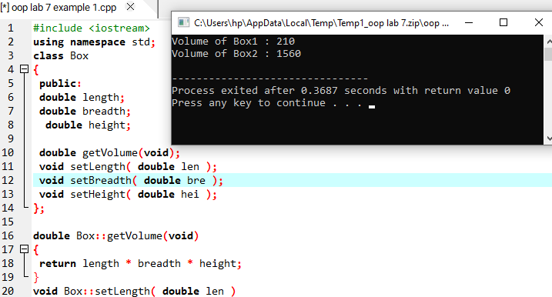

Example # 02

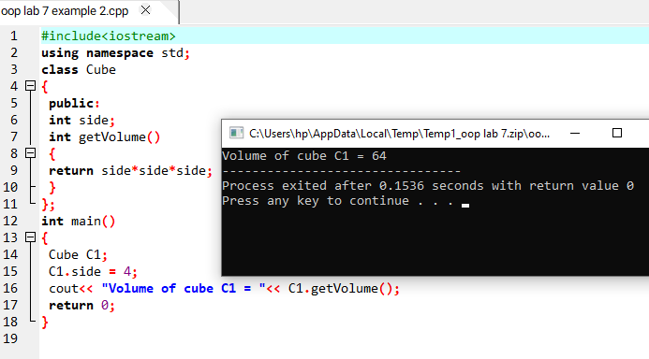

Example # 03

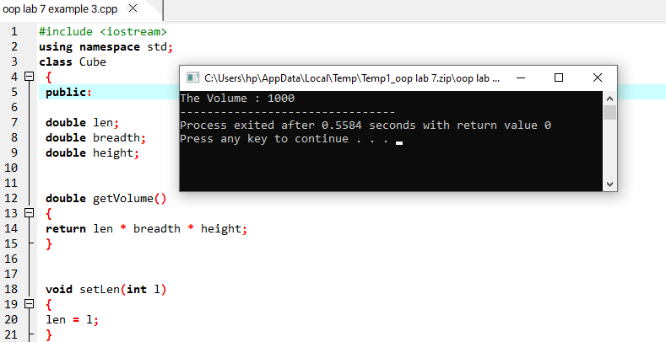

Example # 04

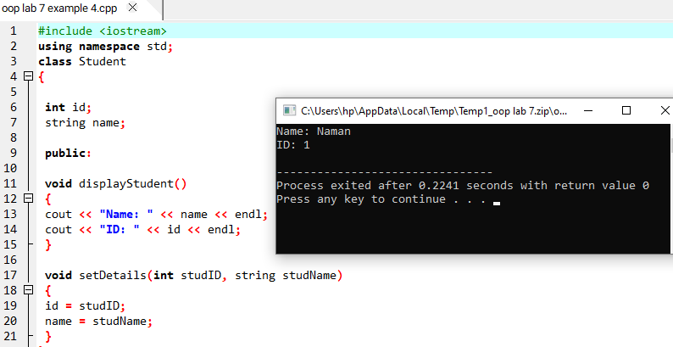

Example # 05

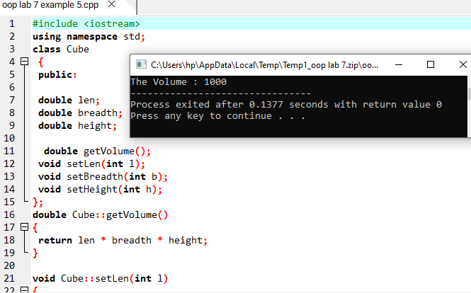

Example # 06

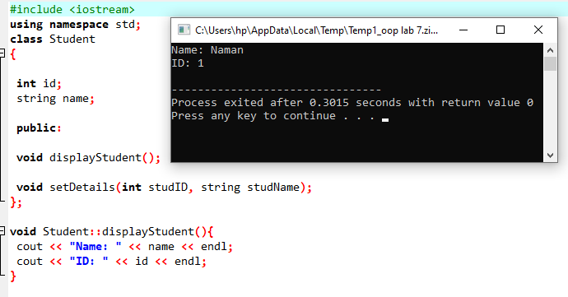

Example # 07

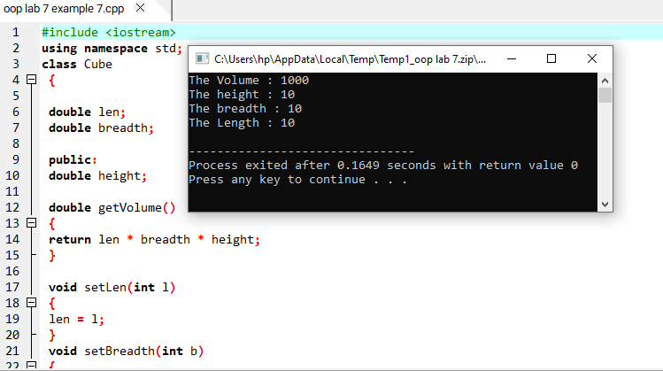

Example # 08

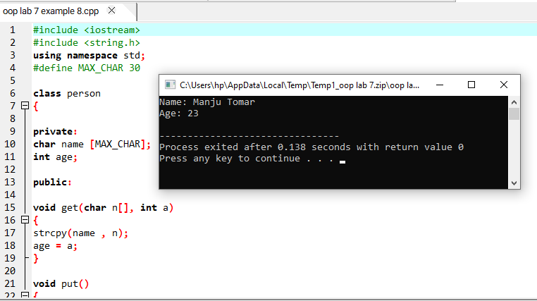

Example # 09

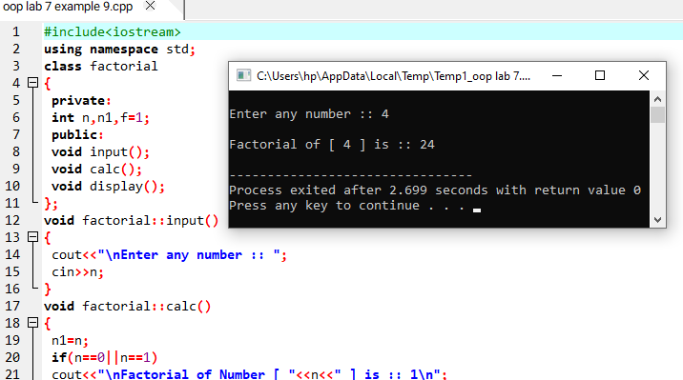

Review Questions

Question # 01

Solved all lab examples in software and check their output by your lab instructor.?

Answer

All done .

Question # 02

Write a C++ program to find Reverse of a Number by defining the function outside the class ?

Answer

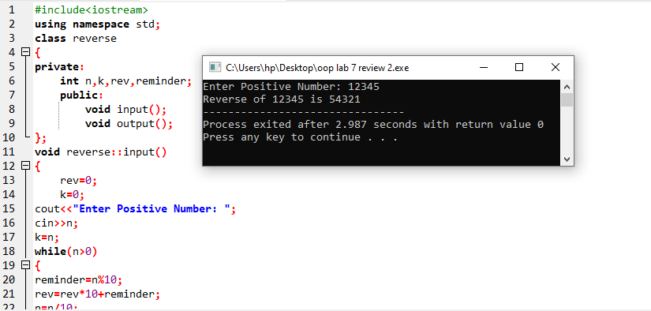

Question # 03

Write a C++ Program to find Largest of three Numbers by defining the functions inside class.?

Answer

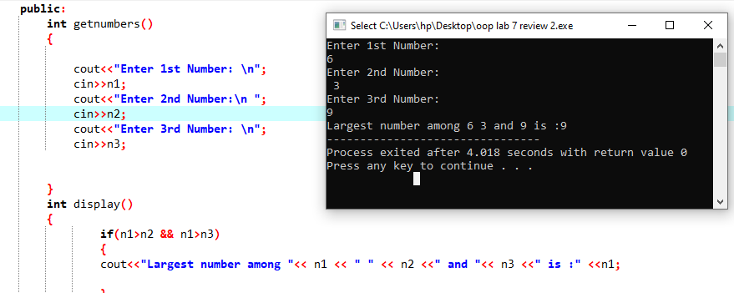

Question # 04

Write a C++ Program using class to input the date (day, year , month) from user using input function and display the result using display function?

Answer

